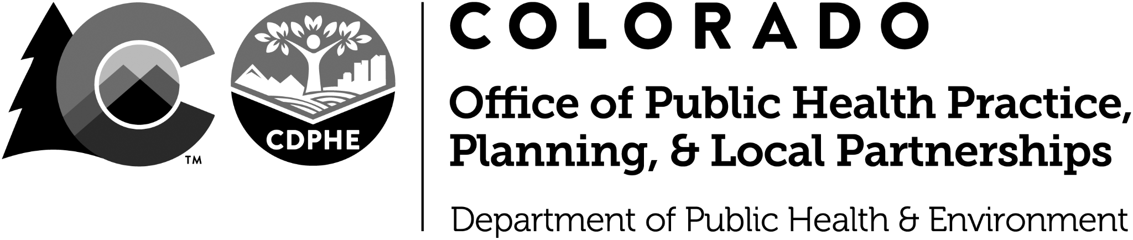
Logic Model Guidance & Template
Logic Model Field | Guidance | Examples
Overarching Goal(s) | In this box, enter the overarching goal(s) of the work reflected in the model. These typically will not be completely within a group’s sphere of control, but the group is working to impact these overarching goals (i.e., improve maternal wellness, reduce the prevalence of low birth weight, reduce the prevalence of diabetes, etc.). These are often population-level, broad-based health outcomes. | Reduce the rate of obesity in children  Improve maternal wellness  Reduce the prevalence of diabetes  Improve the physical and mental well-being of Colorado youth
Inputs | Entries in this column should describe the existing resources that are available prior to implementing the action plan. These could be reflective of human resources, technology, time, equipment, etc. | Grant funding from CHF  Staff time  Childhood obesity experts in CDPHE  OBGYN network  Evidence-based materials for DSME
Strategies | These are broad approaches by which the responsible organizations will achieve its goals. Describe clusters of activities and tasks that will be conducted in order to accomplish the outcomes. These are not the specific day to day activities or week to week tasks required to implement the strategies. Rather, they describe clusters of activities and tasks that will be conducted in order to accomplish the outcomes. Strategies should be written using a verb. Strategies will become more detailed in your action plan by describing their associated milestones/key activities. | Develop and disseminate model policies  Educate on depression screening during pregnancy  Fund community-based DSME classes
Outputs - reach | Participation – this column should describe the immediate target population associated with the strategy. In other words, it will describe who is reached by the strategy.
Outcomes | Outcomes refer to the changes that are expected to occur as a direct result of implementing the strategies. Often, they reflect a change in attitudes, behaviors, knowledge, skills, status, or level of functioning. Outcomes should be written as a state of existence. In other words, they should describe what has changed.  Short term outcomes: Typically can be accomplished in one to three years and are often expressed at the level of individual change.  Medium term outcomes: May take four to six years. These usually build on the progress expected by the short-term outcomes.  Outcomes are written as objectives in your action plan. | Short Term  Improved school administrators’ understanding about effective physical activity policies  Increased provider intent to refer for screening  Increased availability of DSME classes  Mid Term  More schools with physical activity policies.  More at-risk pregnant women referred for screening.  Quicker diagnosis and treatment times for depressed moms.  Increased number of people with diabetes attending DSME
Impact | Impacts are the long-term changes that are expected to result if the strategies are carried out effectively and/or sustained. These are often about conditions, and may take 7-10 years to accomplish. | Increased rates of physical activity for kids.  Reduced rate of untreated pregnancy-related depression.  Improved self-management behavior for people with diabetes

Priority area:

Goal:

Input: | Strategies | Output-Reach | Short term Outcome | Mid term Outcome | Long Term Impact
Assumption(s):

Process notes:

CHAPS V3. 2019

